**Lab Manual- Azure CLI for Solution Developer**

**Prepared for**:

**Date:** 18th Nov 2018

**Prepared by:** Aditi Shrivastava

Document Name: Lab Manual

**Document Number** SysOpsLab311

**Contributor:**

Table of Contents

1 OBJECTIVE 3

2 PRE-REQUISISTE 3

3 Connect to Azure with Azure Cli 3

3.1 **Azure Resource Group** 6

3.2 **Azure VM Comamnd** 8

# OBJECTIVE

Azure CLI is a cross-platform command line tool, that is used to manage and administrate Microsoft Azure. It doesn’t replace PowerShell but provides an alternative to using managing Azure from the command line. You can still continue using PowerShell, the APIs and the Azure Portal just like before. Azure CLI provides some tangible benefits over these, especially over PowerShell in that it’s very nimble and can be quickly installed on almost any platform.This Lab will cover the basics of configuring Azure cli.

Actually an Azure CLI command has the following structure:

* **a command group** which represents an Azure service and which can be the composition of subgroups
* **a command** which is the action you want to do on the group / Azure service
* arguments optionally which are a list of parameter names and values

# PRE-REQUISISTE

* Accounts in Azure
* A local Computer with 4 CPU, 16 GB RAM, 200 GB disk space

# Connect to Azure with Azure Cli

1. Open command prompt in Admin Mode and type below command

az login

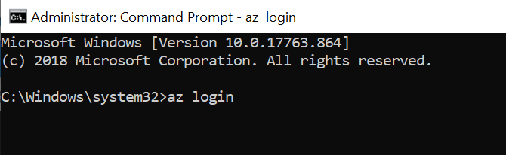

1. It open the login screen in browser and just type your username password

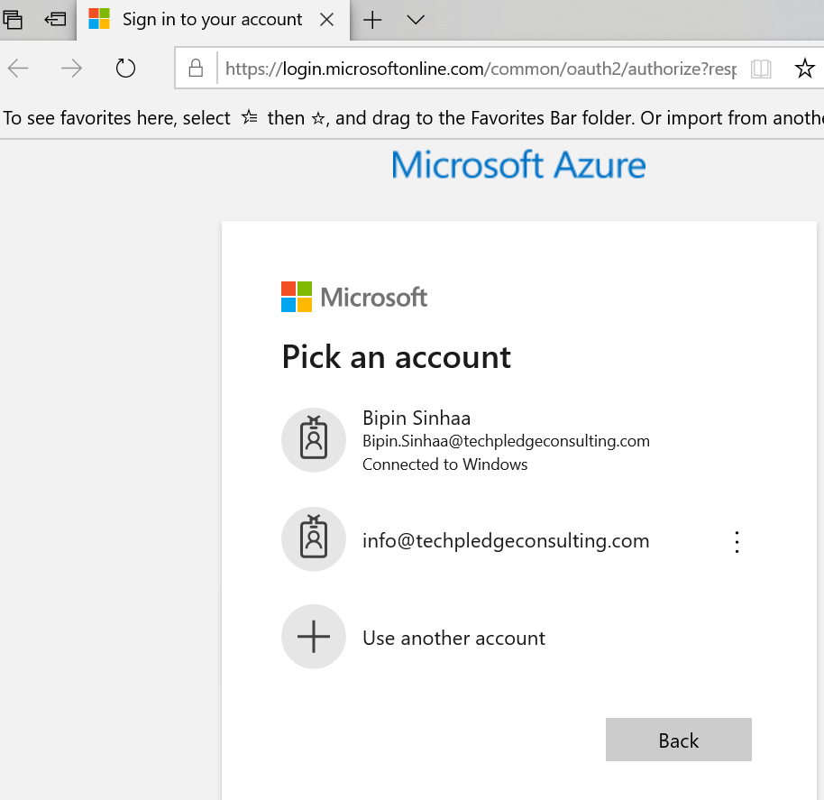

1. Once you get successfully authenticate you get this message on command

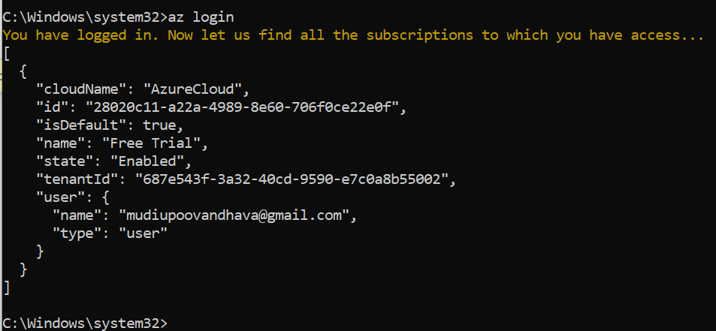

You can also login using below command

az login -u johndoe@contoso.com -p VerySecret

1. Type below command to check the current Login user ( Notice the output format it is called **Jason** format which is default)

az account list –all

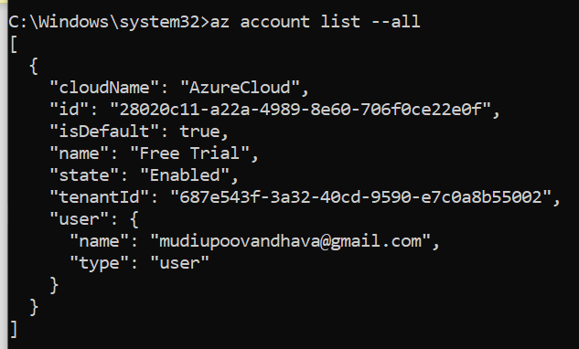

1. Now type the same command with different output format **table**

az account list --all --output table

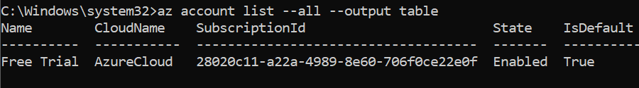

1. You can change the default setting like output format like table type below command and press **Y** , press **3** when asking outper format

az configure

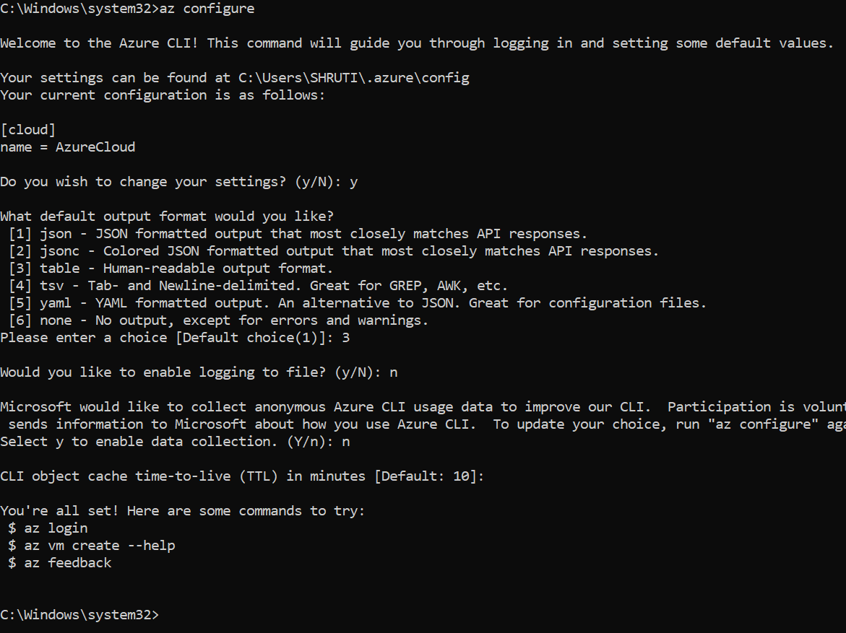

## **Azure Resource Group**

* To list all Resource Groups, use:

az group list

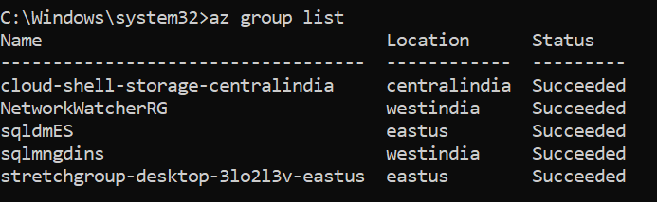

* To create a new Resource Group Name **Azclidemo** at **EASUS** region , type:

az group create --name azcclidemo --location eastus

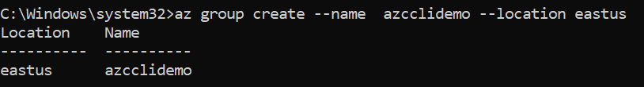

* Now list the resources group again to see your created Resources group **Azclidemo**

az group list

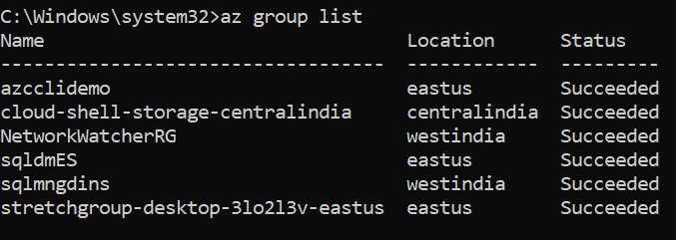

1. Now to delete the Resources group **Azclidemo** type below command and type **list command** to verify

az group delete --resource-group azcclidemo --yes --no-wait

az group list

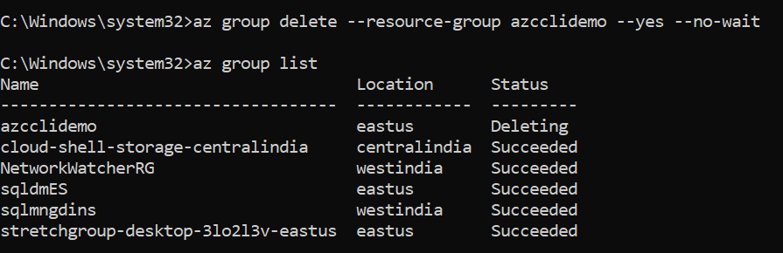

## **Azure VM Comamnd**

* Type below command to create a vm name **myVM** in resource group **sqldmES** resource group with default user **demouser**

AZ vm create --resource-group "DemoRG" --name "myVM" --image "Win2016Datacenter" --admin-username "Demouser" --admin-password "Demouser@123" --location eastus



* To list all **VM** type below command

az vm list

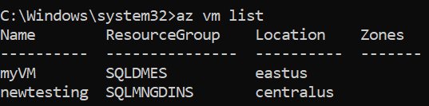

* To stop **VM** type below command

az vm stop --resource-group **DemoRG** --name **myVM**

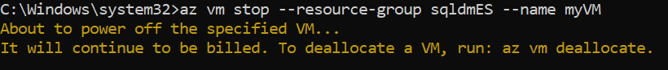

* To start **VM** type below command

az vm start --resource-group **DemoRG**  --name myVM



* To Delete **VM** type below command

az vm delete --resource-group **demoRG** --name **myVM**

